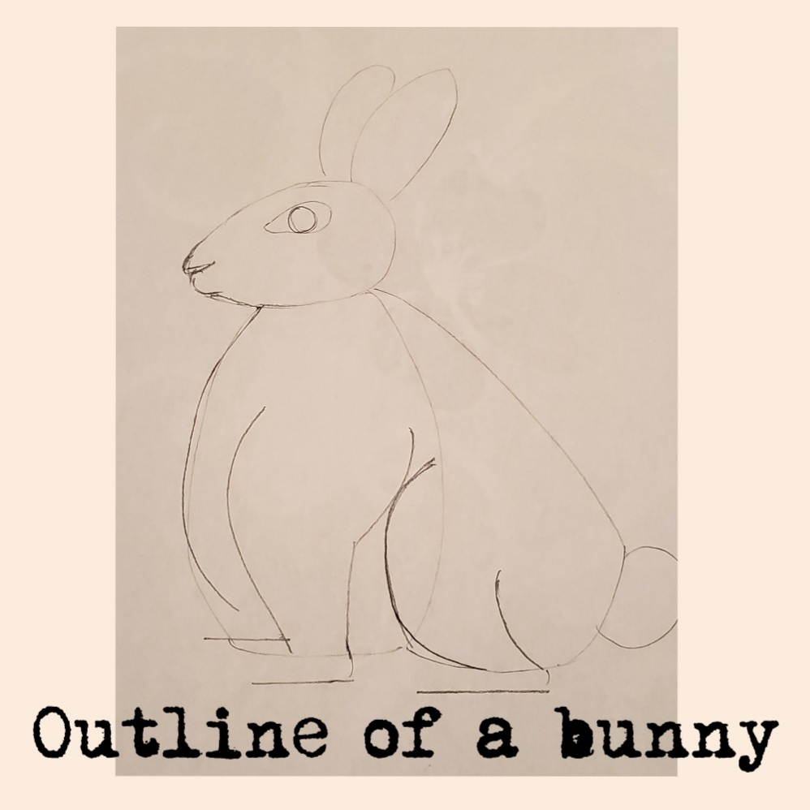

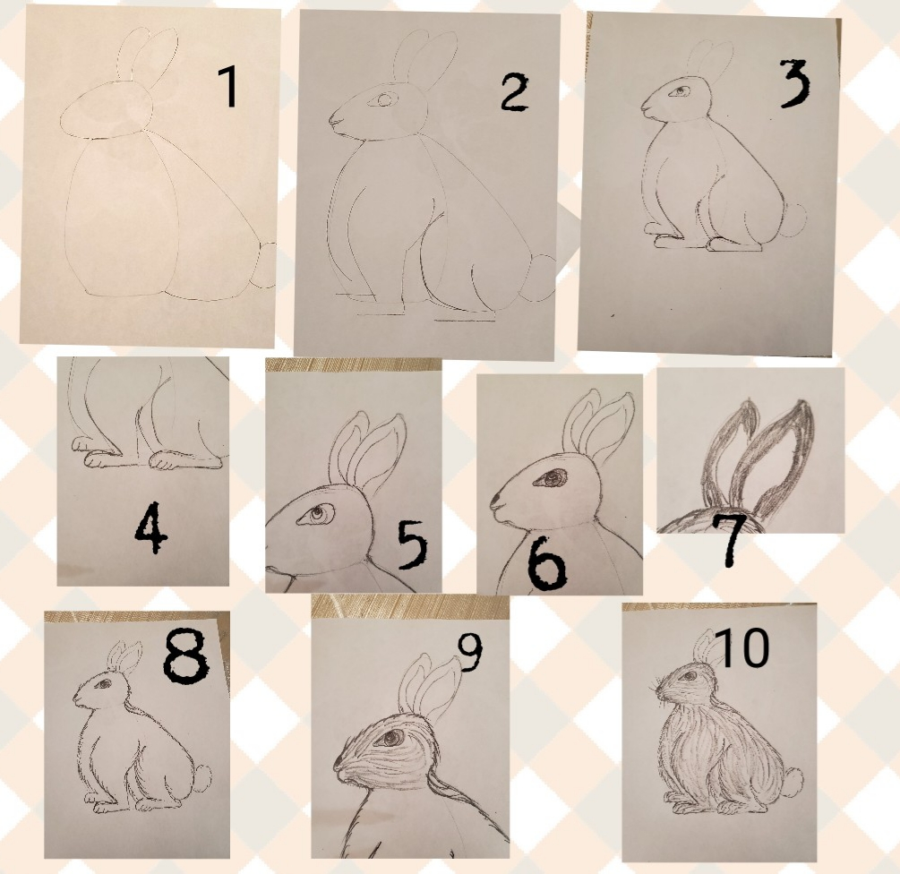
- Start by sketching the outline basic shapes.
- Add the paws
- Darken the outline and erase the lines not needed any more
- Add the fingers on the paws,
- Add detail to the eyes
- Darken the eyeballs
- Add value to the ears
- Start adding the fur texture to the outline.
- Add fur texture to the face by going along the shape of the face
- Add texture to the whole body.

